Specification and automatic generation of Interconnect, test bench, reference model and their interfaces for chip design and system-level design

The RTL coding tasks falls into two categories:
- Algorithmic: the core data-paths and control logic that differentiates your implementation from the competition: For example: your MPEG implementation, your traffic manager, your cache.
- Chip design and verification infrastructure: all the additional code, constants, and connectivity required to turn your algorithm implementation into a functional chip. For example: block inter-connect, programmable register access, instruction set mapping, block test-benches, state elements, ...

The algorithm implementations change dramatically from project to project. Chip and verification infrastructure creation is repetitive by nature and does not change much from project to project. Design and verification infrastructure needs to be consistent and common across the domains in which it is used such as RTL design, reference modeling, verification, and software tool development. Infrastructure is used for seamless communication between the different domains.

The FPL solution automates the chip design and verification infrastructure generation tasks. The key characteristics of the solution are as follows:
- Single source input to describe all of the design and verfication infrastructure on a given chip design project.
- Integrated software tool to automatically generate the necessary infrastructure.
- Integrated software tool to check the consistency of the single source input
- Consistent set of interfaces across RTL design, verification, reference modeling, and software tool development domains.
- Significant reduction in setup and maintenance time for infrastructure specification and generation.

Definitions (please see figure 1)
- RTL Design
- Design under test (DUT) (RTL1):
- The RTL design is instantiated in the test bench. The instantiated design is defined as the “design under test”.
- Interconnect and Design Hierarchy(RTL2)
- A design hierarchy is a hierarchy of functional blocks to manage the complexity of the underlying design.
- Module interfaces: Input and output interfaces for a design
- RTL instantiations: The set of actual connections from one module to another
- Interconnect - functional blocks connected to one another to facilitate the transfer of information which is processed by an algorithmic implementation contained in the functional blocks.
- State: Units contain memories, registers, register files the contents of which are updated on a clock edge and optional enables. The collection of one or more state elements in a unit can be captured known as the current state.
- Generated constants, generated containers and generated logic inside of DUT (RTL3).
  - Bit ranges are used for signals, registers, memories, register files, and FIFO’s.
- User logic (RTL4).
  - The algorithmic logic instantiated inside of the functional blocks.
- Verification components
- Used in the reference model and the test bench.
- Vectors: Set of input or output ports associated with a unit whose values are captured on a certain event (e.g. valid bit is asserted or every clock cycle). The vector capture mechanism for the entire simulation is turned on at a certain event or time (e.g. after reset). The vector capture for the entire simulation is shut off at another event (e.g. maximum number of events or clocks occurred or maximum number of errors).
- There are 2 types of vectors – stimulus and expected. Stimulus vectors drive the inputs of the DUT. Expected vectors are compared against the outputs of the DUT either at a clock edge (cycle accurate vector) or on an event (transaction accurate vector).
- State data: Is the state captured at the clock edge or on an event. A set of registers or a register file in a unit whose values are captured on a certain event. The state data capture mechanism for the entire simulation is turned on at a certain event or time (e.g. after reset). The state data capture for the entire simulation is shut off at another event (e.g. maximum number of events or clocks occurred or maximum number of errors).
- Test benches
- Top-level test bench: a container that holds the elements of the test bench. See the remaining elements in this section (TB1).
- DUT instantiation: A unit instance in the chip design hierarchy is instantiated in a test bench and connected to the other components in the test bench.
- Stimulus memory instantiation TB4: Stimulus vector memory contains the set of stimulus vectors generated by the reference model and the header which contains the vector id
- Expected memory instantiation TB6: Expected vector memory contains the set of expected vectors generated by the reference model and the header which contains the vector id
- Architectural state memory: contains the expected architectural state (TB5).
- Comparators
  - Expected Vector comparator TB3: Vector comparator which compares DUT output vector and expected vector memory on an event or clock and generates a set of match and mismatch signals
  - State data comparator TB2: State comparator which compares DUT state and state memory on an event or clock and generates a set of match and mismatch signals
- Test bench – RTL design interface: The stimulus vector memory is connected to the DUT inputs and the DUT outputs are connected to the expected vector comparator

- Reference Model
- Reference model simulator (RM1)
  - A simulator that models the functionality of the chip design being verified. The simulator can be either cycle or transaction accurate.
- Units: Functional
- Units that are used to model the behavior of an equivalent hardware unit at the interfaces and optionally the internal state
- Interconnect and Design Hierarchy (RM5/RM6)
  - A design hierarchy is a hierarchy of functional blocks to manage the complexity of the underlying design.
    - Module interfaces: Input and output interfaces for a design
    - RTL instantiations: The set of actual connections from one module to another
  - Interconnect
  - Functional blocks connected to one another to facilitate the transfer of information which is processed by an algorithmic implementation contained in the functional blocks.
- Generated constants, generated components, and generated logic inside of the units (RM7).
- User logic (RM8).
  - The algorithmic logic instantiated inside of the functional blocks.
- State (e.g. memories, register files) – see definition 2c above
- Vector writers
  - Stimulus RM2: Stimulus vector writer writes out stimulus vectors based on an event or clock to a file or socket
  - Expected RM4: Expected vector writer writes out expected vectors based on an event or clock to a file or socket
  - State data writer – expected RM3: Arch state writer writes out arch state based on an event or clock to a file or socket
- Communication Mechanism Between the Reference model and Test bench
- Vectors and sockets or files: see definition 3b above.
  - A unit’s input vector (C1-the inputs to a unit) in the reference model are captured every cycle and are written to a file or socket which is then read by the test bench and then are applied to the inputs of the DUT.
  - A unit’s output vector (C2-the outputs of a unit) of the reference model are captured either every cycle or on an event and are written to a file or socket which is then compared to the outputs of the DUT in the test bench.
  - State data (C3).A state data element in a unit in the reference model is captured every cycle or on an event and is written to a file or socket which is then compared in the test bench to the corresponding state in the DUT.

- Co-simulation: Inserting an RTL module inline in the reference model

- 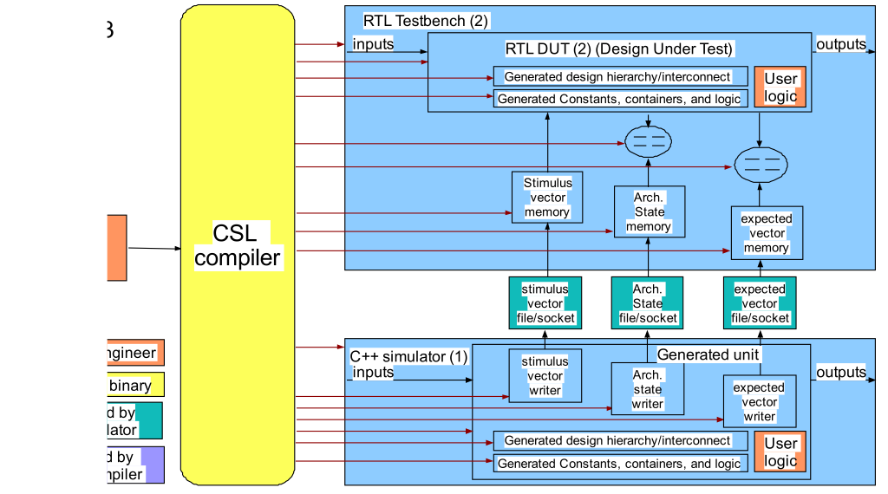Figure 1. Overview of infrastructure for RTL design, test benches, reference modeling

C++

FPL
Compiler

RTL 1

RTL 2

RTL 3

RTL 4

TB 1

TB 2

TB 3

TB 5

TB 4

RM 1

RM 2

RM 3

RM 5

RM 4

RM 6

RM 7

TB 6

RM 7

C1

C2

C3

Current method and issues
A fragmented design flow exists in RTL design teams as shown in figure 2.
- Currently the design, test bench and reference model implementations are built by separate teams using separate tools
- Inter-domain interfaces, constants, vector events, etc. are maintained manually
- Significant duplication of effort
- Lack of consistency

Maintenance is also a big issue, particularly for chip and verification infrastructure. Design changes must be reflected in C++ models, verification suites, software memory maps, and chip documentation etc. Figure 2 shows an example set of separate specifications that must be maintained in parallel.Changing the same information in multiple places is tedious and error-prone. Changing the information in one place saves time in many ways.
- 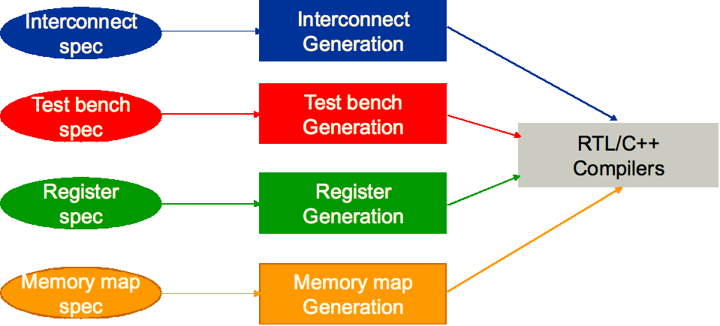
Figure 2. Fragmented design flow

Figure 3 shows the issues related to the exchange of information between C++ ref model team, verification team and design team. They all must create interfaces between the 3 different domains manually, make changes manually and debug the interface mismatches between the 3 different domains manually which results in significant productivity loss).

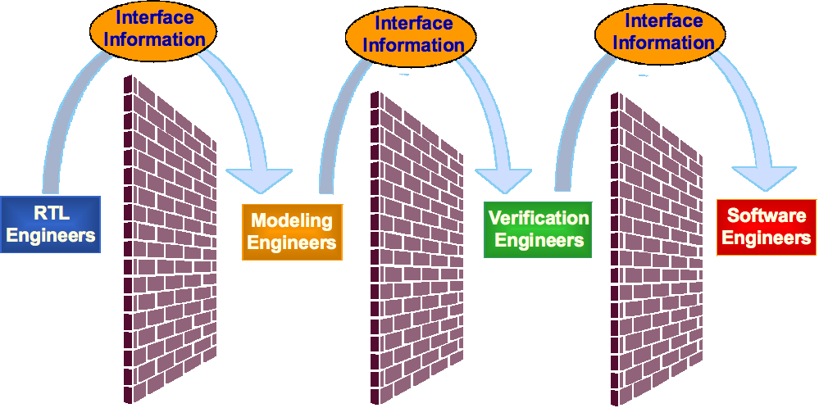
Figure 3. Information exchange between different teams on a project

New method
The FPL design platform enables the automatic generation of the design and verification infrastructure components for a given design (C to infrastructure solution which is highly complementary to a C to gates or C to RTL solution). It includes a super compact input description based on C++, a retargetable compiler, a comprehensive set of hardware building blocks and a complete methodology. The solution completely automates the generation of key building blocks such as design hierarchy, interconnect, test benches, memory maps, register files, FIFOs, buses, etc. In addition, the infrastructure generated is in the form of synthesizable RTL and C++ which can be seamlessly integrated into existing design environments with minimal overhead. This high degree of automation will enable a very high level of design & verification productivity and frees up the designers to focus on the highest value-added activity of designing the actual design IP on a project (the algorithmic/control blocks on a chip).

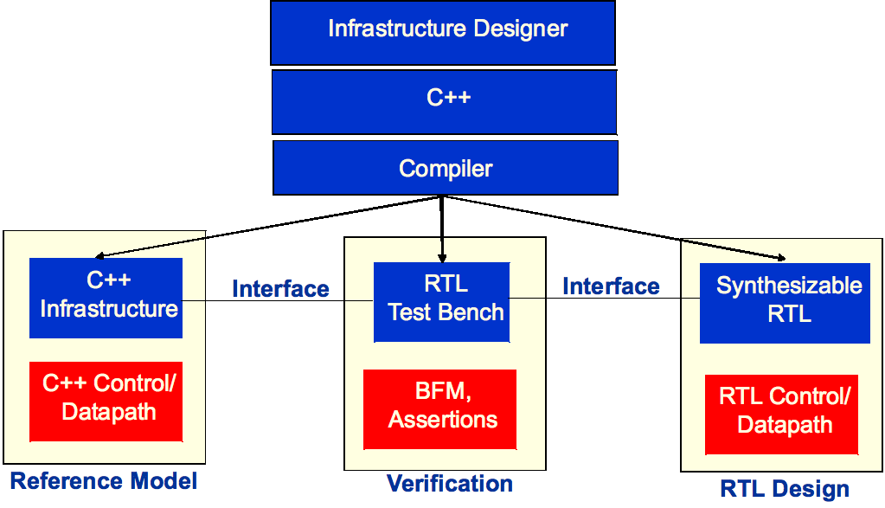Figure 4. FPL Flow diagram

FPL Flow diagram
The flow show in figure 4 is described in the following section:
- Infrastructure designer
  - A GUI interface that is used to create the design hierarchy, interconnect, components in functional units, and constants.
- C++ code
  - The GUI automatically generates highly compact C++ code that specifies the design and verification infrastructure for a given design. Alternatively, the C++ code can be written by hand. The C++ code has some very powerful built-in constructs to fully describe the infrastructure in the form of interconnect, design hierarchy, memory maps, etc.
- Compiler
  - The compiler compiles the generated or handwritten C++ code
- Generated components
  - Reference model - see definition section 5 above. The compiler automatically generates the hierarchy, interconnect, containers, and constants for the C++ reference model. In addition, the vector readers and writers, state data writers are automatically generated. The generated readers and writers are equivalent to the corresponding elements in the test bench. The user then writes the C++ code representing the algorithms and connects it to the infrastructure code in order to complete the reference model.
  - Verification components - see definition in section 3 and 4 above. The compiler automatically generates test benches at each level of the design hierarchy where specified. The compiler automatically generates the components in the test bench to connect the test bench to the reference model and instantiates the design under test. The user can optionally add components such as bus functional models and assertions to the automatically generated test bench.
  - Synthesizable RTL - see definition in section 2 above The compiler automatically generates the hierarchy, interconnect, containers, and constants for the RTL design. The user then writes the RTL code representing the algorithms and connects it to the infrastructure code in order to complete the reference model.
  - Co-simulation using a reference model and an inline RTL DUT.

Reference model, vector/state data, and RTL test bench flow
Our example will show how a reference model unit b can be replaced by an RTL unit. Example communication mechanisms between the reference model and the RTL DUT include a shared memory or a socket. In figure 5 there are three units in a reference model and RTL design (a,b,c). In each model unit A is connected to unit B and unit B is connected to unit C.

- 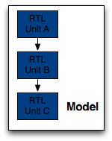
Figure 5. Example design hierarchy

In figure 6 unit B in the reference model is replaced by an equivalent RTL unit B.
  - The outputs of unit A in the reference model are connected through a communication mechanism (a socket or shared memory) to the inputs of unit B in the RTL model
  - The outputs of RTL unit B are connected through a communication mechanism (a socket or shared memory) to the inputs of the unit C in the reference model.
  - The reference model simulator and the RTL simulator are then executed.
- 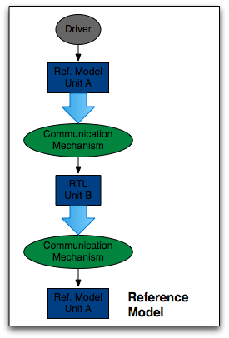
Figure 6. Co-simulation model: using a reference model to drive the inputs of an RTL DUT directly.

Reference model, vector/state data, and RTL test bench methodology
The verification methodology flow shown in Figure 7 uses a reference model to verify an RTL DUT in a test bench. The reference model generates stimulus and expected results and state data.The figure shows the connections between the verification component writers in the reference model and the readers in the RTL test bench. In addition the output comparator is shown.
The simulation steps are as follows:
  - The reference model and driver are reset by a master controller.
  - The RTL DUT is reset by the master controller.
  - Unit B in a hierarchical reference model is replaced by an equivalent RTL unit.
  - The connections between the the reference model and the RTL DUT are created as follows:
- In this example there are three units in a reference model and RTL design (a,b,c). In each model unit a is connected to unit b and unit b is connected to unit c.
- The outputs of unit a in the reference model are connected through a communication mechanism (a socket or shared memory) to the inputs of unit b in the RTL model and its outputs are connected through a communication mechanism (a socket or shared memory) to the inputs of the unit c in the reference model.
- The reference model simulator and the RTL simulator are then executed in either the same process if a shared memory communication mechanism is used or in different processes if a socket is used.
- The driver creates stimulus for the reference model inputs which drive the inputs of unit A in the reference model.
- The automatically generated vector writer driven by the unit A outputs (stimulus vectors) which are captured on each transaction and sends the transactions to the stimulus memory (buffer) in the test bench.
- Unit A processes the stimulus and generates transactions on its outputs.
- The vector writer driven by the outputs of unit A (expected vectors) captures every transaction and sends the transactions to the expected memory (buffer) in the test bench.
- A controller reads the stimulus memory which drives the DUT inputs.
- The DUT processes the input(s) and produces transaction(s).
- For each valid transaction (e.g. based on the same event - clock or boolean event - as the reference model expected vector writer).
- The output of the DUT is compared to the output of the expected memory.
- The matches and mismatches are captured by the match and mismatch reporter.
  - 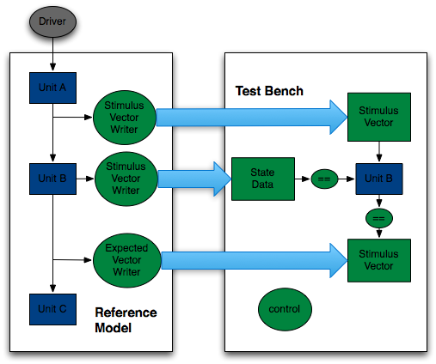
  - Figure 7. Verification methodology flow using separate reference models and test benches.

Verification methodology ???
The following method facilitates an incremental bottom up verification methodology. The first infrastructure component that is developed is the interconnect and design hierarchy. The units in the design hierarchy are the containers for the other chip design elements, including other infrastructure elements such as memory map elements (e.g. address decoders, register files, registers). The unit interfaces are used to instantiate the RTL DUT in the RTL test benches. The design hierarchy is used to construct the reference model.

A project uses the following methodology to create the design and verification infrastructure using the FPL solution. BRING OUT THE KEY CHARACTERISTICS OF EACH STEP?????
- Create the design hierarchy and interconnect specification which serve as the foundation for most components in a design
  - Units are containers.
  - Units have interfaces
  - Interconnect connects the units
  - Test benches instantiate units using the unit interface information
- Create Registers/register file: added to design hierarchy in RTL and optionally in C++ ref model
  - Can be created using the same bit range and field objects to create signals and ports
- Create Memory map
  - Addressable objects (e.g. registers/register file) in units can be added to the memory map automatically
  - Unit IDs can be manually or automatically assigned to units
  - Generates equivalent constants and functions in C++ and RTL
- Create verification components (vectors and state data) and associate them with existing units
- Create test bench specification
  - No need to specify vector names or state data names: inferred from DUT
  - Automatically connected to C++ reference model vectors/state data and DUT
  - Parameterizable (e.g. set # of errors/simulation cycles)
- Compile the specifications and generate the following –
  - C++ reference model, test benches, RTL interconnect
  - Usage model
    - Compile the C++ reference model.
    - Compile the RTL.
    - Alternatively
      - Simulate the C++ reference model, generate the vector and state data files.
      - Simulate the RTL test bench using the vector and state data files.
      - View the results and then fix any problems.

Benefits
  - Highly compact specification: 10-30X reduction in lines of code compared to RTL
  - Hierarchy, interfaces, and connections are separated which makes it easier to maintain and make changes
  - 20X-50X reduction in effort required to develop and maintain the code
  - The interconnect and design hierarchy specification are implemented once instead of implementing the infrastructure in each domain – test benches, reference models, etc.
    - Capture once, Reuse everywhere
    - Make changes in a single place and propagate everywhere
    - Consistent set of interfaces across several domains
    - No parallel book keeping
  - Test benches are automatically connected to the generated C++ Reference Model and RTL design with a highly compact specification (very few lines of code)
  - A consistent set of interfaces are generated automatically (RTL, C++, test bench)
  - The generated design, test bench and reference model code is consistent by construction and no additional work is required to integrate the components
  - Single tool to generate all of the infrastructure automatically.
  - Applicable to all design environments (FPGA, ASIC, SoC, Microprocessor, etc.)
  - Generates industry standard RTL (Verilog, VHDL, SystemC, System Verilog) which can be easily integrated into existing design flows.

